20XX-01-XXXX

3-D Horn

Abstract

3-D horn is a vehicle to vehicle communication-based technology which helps in reducing the noise pollution, which occurs, due to honking of automobile horns by letting only the drivers of the automobile to hear the horns and not the whole environment around him. To achieve this, several relatively small horn speakers are placed inside the car. These speakers are controlled by drivers of other cars. In this way honking will be heard only by the drivers. The most unique feature of this technology is the 3-D effect caused by the speakers which will let the driver know the location of the outside car which is honking. The 3-D effect is achieved by varying the intensity and proper allotment of sound to the positioned speakers in such a way that it will give the feel of the location of the outside car to the driver. Human detection is another important feature this technology provides. It will recognize whether the horn is honked for an automobile or for a human. In case of human an external horn will be honked otherwise 3-D horn will be honked. A combination of GPS and RADAR is used to achieve this functionality.

Introduction

Noise pollution is the high-prior issue for every living organism in the world. Some of the state government agencies such as environmental protection agency (EPA) are taking initiatives to control the noise generated through transportation vehicles. The vehicle manufacturers are also manufacturing and implementing horns in their vehicles to warn others of the vehicle's approach. However, its usage totally depends on the driver of the vehicle else excess use of horn will turn to the noise. Hence, honking of the cars has a significant contribution in the world’s total noise pollution. Few years down the line, number of vehicles running on the road expected to be increasing exponentially along with the honking. On account of this, reducing the honking-based noise is the top-prior need in today’s scenario.

To tackle this situation, 3-D HORN is one of the most effective technology one can use. The concept of 3-D horn is entirely opposite to that of normal horns currently in use. Instead of placing the horn’s speaker outside the vehicle, we are placing an array of relatively small horn’s speaker inside the car. These arrays of speakers will be honked by the surrounding cars. It means 3-D horn-based outside cars will be able to control the horn’s speaker inside transmitting car. In this way, the surrounding environment will not be affected by the sound of big horns, which are normally placed outside the car. Here, nobody will listen the horn except the driver of transmitting car that yields to resolve our purpose.

Furthermore, the transmitting car’s driver will also be able to sense the location of the surrounding car because of the 3-D effect of the arrangement of speakers inside the car.

The 3-D Effect

The 3-D effect of this technology makes it different and unique from other technologies and enable to solve the noise pollution. Due to this 3-D effect, the driver will not know that he is sitting in a car installed with this technology. The 3-D surround sound produced by the array of speakers will make it so natural that the driver will feel as if some outside car is honking. Also, to get the location of honking vehicle, we need a mechanism that can easily detects the location of the outside car. Location mainly includes 2 parameters viz. distance and angle. To give the feel of the distance of the outside car, we are varying the intensity of the sound emitted by the speakers, and for the angle of the car, sound will be allotted to different positioned speakers in such a way that it will give the feel of the distance and angle of the outside car with respect to transmitting car. We need minimum 12 number of small speakers (3 on each side) inside the car to accomplish this task. Moreover, the allotment of sound to the speakers will give the feel of the direction of the outside honking car. Here, figure 1 shows an example of such a scenario, i.e. there are 9 cars moving in the same direction. The car marked green is TRANSMITTING CAR and other cars are termed as RECEIVER CAR. In the case shown, TRANSMITTING CAR will act as master and RECEIVER CAR will act as slave. Position of horn’s speaker is also shown by red dots. Each car is having 12 horn’s speakers distributed uniformly inside the car. The horn marked green is the active horn, which means, these are the horns currently honking inside their respective car. Consider an example of car 2. TRANSMITTING CAR is just behind car 2, therefore the allotment of sound goes to the three horn speakers situated at the back of car 2. Same goes with all the other cars shown in the figure 1.

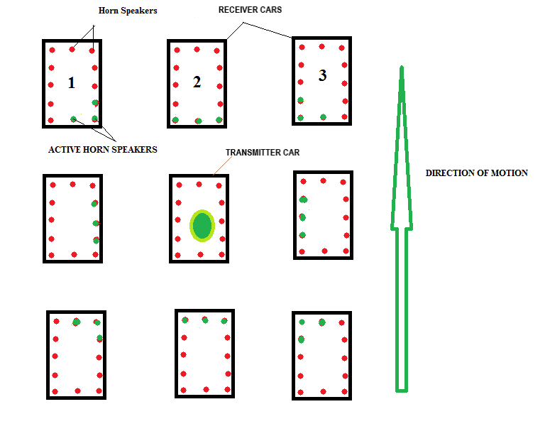Figure 1. Positions of Receiver cars around Transmitter car.

In this way 3-D effect is achieved without being known by the driver and the sound will be heard only by the drivers, thus reducing the noise pollution to a very low level.

Sequence of Flow

Starting from t=0 when a car driver presses its horn button to t=t when 3-D horns are activated, given below is a flowchart showing the sequence of the whole process which takes place between two cars named as TRANSMITTING CAR and RECEIVER CAR. As shown in the Figure 4, RECEIVER (acts as slave) is continuously waiting for the signal for horn activation. When TRANSMITTING CAR driver presses the horn button (Figure 3), then signal is sent to its GPS to read the coordinates to 5 decimal places to ensure a resolution of 1.1 meters in the coordinates. As soon as coordinates are received, a signal consisting of start of frame, message frame and end of frame is sent via XIGBEE transmitter. Message frame will consist of “horn request data bits” + “GPS coordinates data bits”.

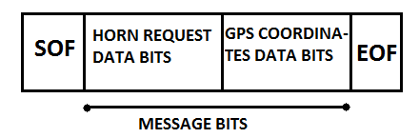

Figure 2. Horn request frame.

XIGBEE signal is sent to a radius of 100 meters which is the expected range of a XIGBEE transmitter. This signal will be received by every vehicle in its radius. RECEIVER CAR receives the signal and extracts the GPS coordinates from the message frame bits. Now the corresponding intensity of sound will be allotted to the array of speakers according to the coordinates received and the process is completed.

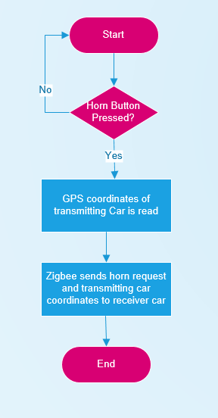

Figure 3. Transmitter car flowchart.

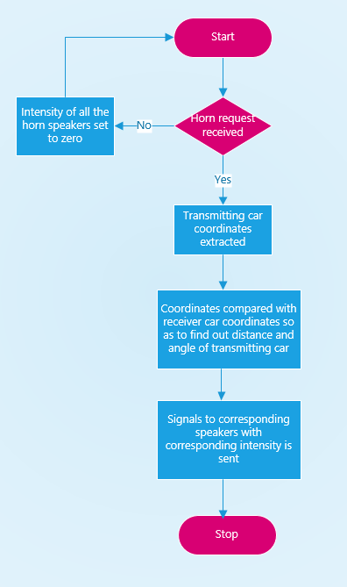

Figure 4. Receiver car flowchart.

Intensity and Allotment of Sound

The 3-D effect works because of the intensity variation and allotment of sound to the corresponding speakers. The engine control unit (ECU) has to decide the intensity and the allotment of sound from the GPS coordinates value received. Following block diagram shows the circuit connection of different components used to achieve this 3-D effect. The green color block is a relay which is activated by the ECU when a speaker is to be allotted the sound of horn. The blue color block is the volume controller or an audio amplifier which is responsible for varying the intensity/volume of the sound so that the driver can visualize the distance of the outside car through the sound produced by the speakers.

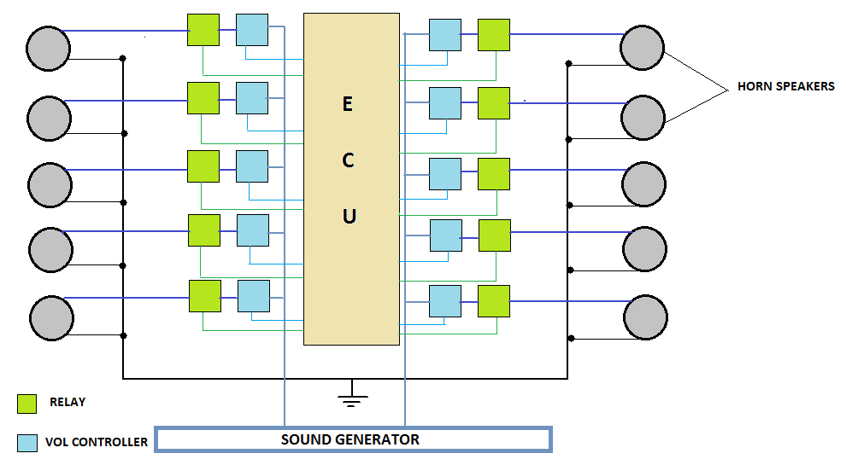

Figure 5. Block diagram.

Sound generator is a device that continuously generates a frequency signal, which is the sound of the horn. It is predefined and cannot be changed. Thus, when GPS coordinates are received, the ECU activates the relay and set the volume controller depending upon the coordinates received so that the 3-D effect can be achieved.

Human Detection

In day to day life use of vehicle horns are not only to warn other vehicles but also for pedestrians include humans and animals. However, in case of humans/animals, this technology alone will not be helpful. We will need an external horn which will be honked by ECU only when a human/animal is in front of the car. Therefore, there is a need to recognize whether the driver is honking for a car or for a human/animal. It typically looks like reading the mind of the driver to find out the reason as to for whom the driver has honked the horn. This requirement is achieved by using combination of RADAR and GPS. Following flowchart shows the sequence of action to be taken to achieve our requirement.

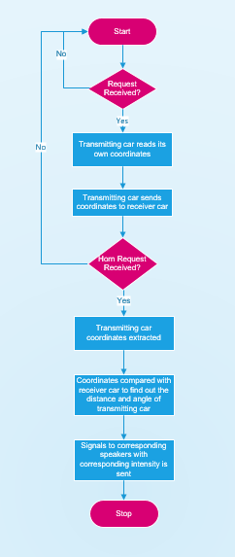

Figure 6. Human detection flowchart for transmitting car.



Figure 7. Human detection flowchart for receiver car.

To detect the presence of human, two types of distance are compared with each other. Distance 1 is calculated by subtracting the coordinates of two cars and Distance 2 is measured with the use of radar. As soon as horn button is pressed, request for coordinates will be sent to receiver car. After receiving the requested coordinates, it is subtracted from TRANSMITTED CAR coordinates to find the distance between the two cars. This distance is called Distance 1. Distance 2 is measured using a radar. If there is no human in front of the car, then both the distances will be equal. If there is any human, then Distance 2 will be less than Distance 1, as Distance 2 is measured using radar. By this method we can distinguish between a car and a human. Depending upon which distance is less, corresponding actions are taken. If Distance 2 is less, then human is in front of the car. In this case external horn will be activated by the ECU. Otherwise, signal for 3-D horn will be sent. Below diagram shows how these two types of distances are measured in presence and absence of human/animal. When there is no human then Distance 1 = Distance 2 otherwise Distance 2 < Distance 1.

Note: Distance 1 is measured using coordinates provided by GPS and Distance 2 is measured using RADAR.

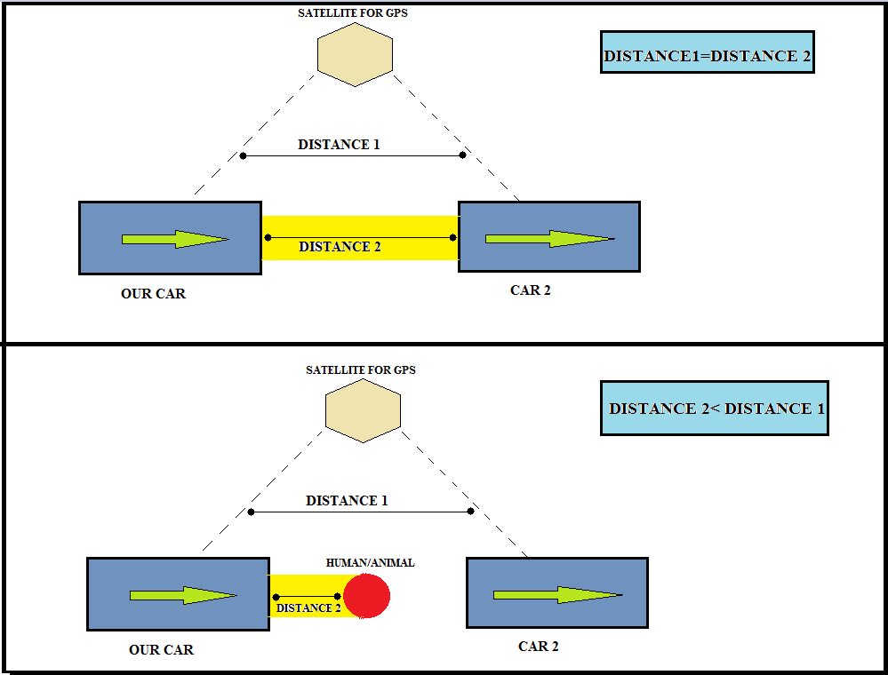

Figure 8. Use of RADAR and GPS for Human detection.

Simulation Result

Simulation for 3-D Horn has been done using MATLAB SIMULINK model. The transmitter car and receiver car has been allotted two sliders each to determine their X and Y coordinates respectively. 12 scopes have been placed around receiver car which acts as internal horn speakers. It will show the intensity and activation of horns. To calculate the distance between the 2 cars, following formula is used:

(1)

To show the waveform of the horn sound, a simple sine wave generator is used with the flexibility to change its amplitude. Simulation results have been shown in 4 different scenarios where the coordinates of transmitter and receiver car is changed with respect to each other. Scope showing a plain horizontal line indicates that these horns are not activated. Scopes showing some waveform indicates the activation of that horn. Intensity of the horn can be judged by looking at the amplitude of wave in the scope.

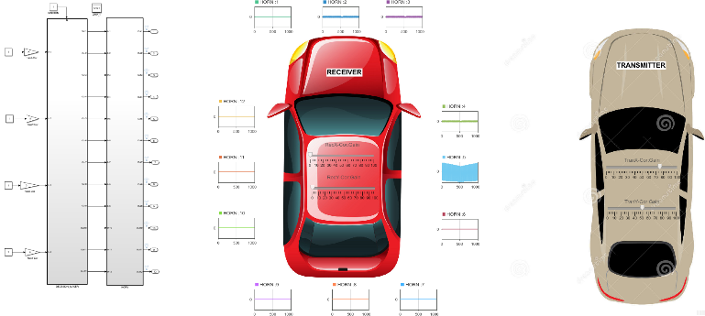Figure 9. MATLAB Simulink model.

Decision for allotting the sound to speakers is made inside decision block as shown in figure 10 and figure 11. First distance is calculated between the two coordinates. Then angle of transmitter car location with respect to receiver car is calculated. Using above calculated information, horn speakers are activated accordingly.

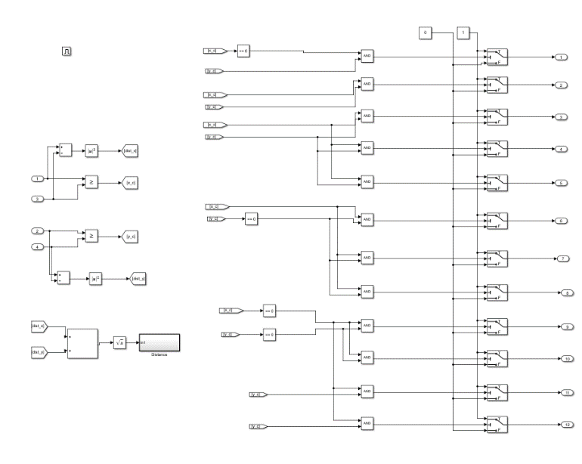

Figure 10. Decision maker block.

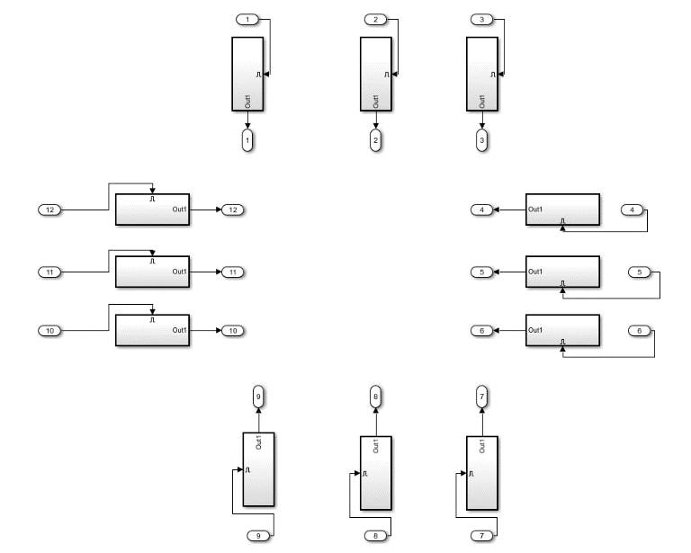

Figure 11. Horn activation block.

Intensity/amplitude derived from above calculation is stored in data store memory block and is then multiplied by the default sine wave, as shown in figure 12. The final outcome is now mapped with the distance and angle calculation from the coordinates.

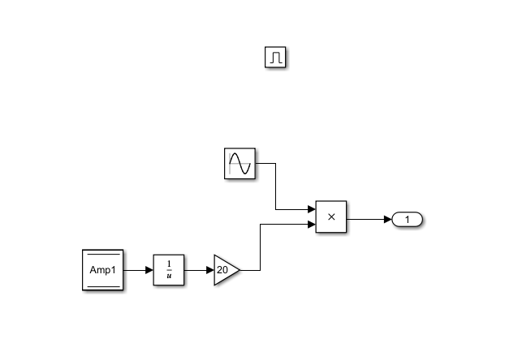

Figure 12: Amplifier block.

Below are 4 different scenarios where coordinates of transmitter car and receiver car are changed and shown in 2-D cartesian plane along with MATLAB SIMULINK model which shows in scope what all horn speakers are activated with what intensity.

.

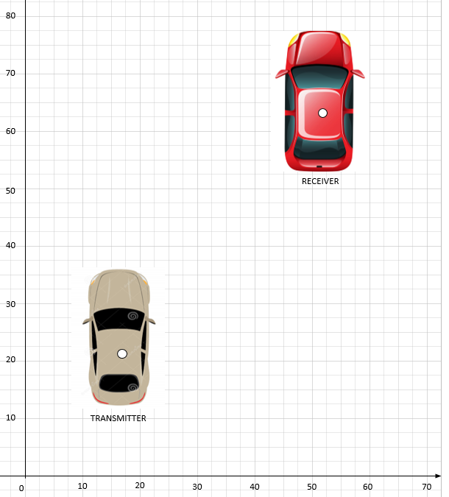

Figure 13. Scenario 1 cartesian plane diagram.

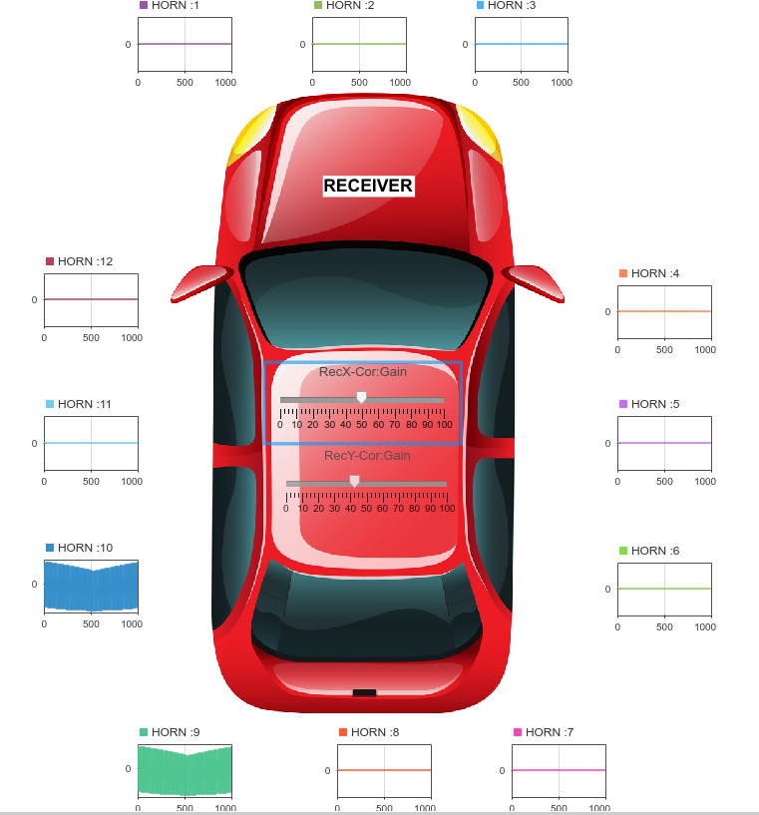

Figure 14. Scenario 1 MATLAB SIMULINK model.

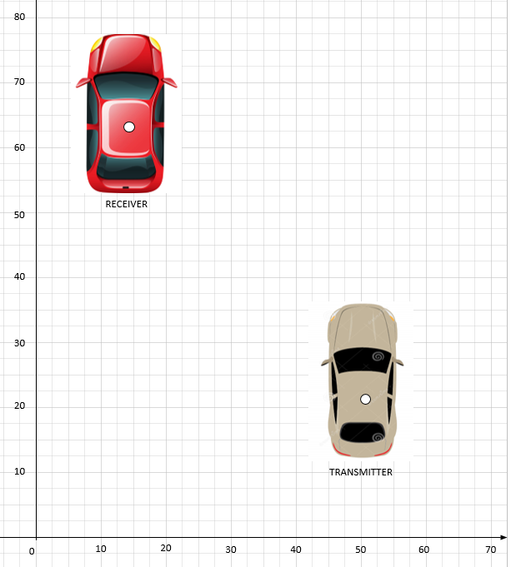

Figure 15. Scenario 2 cartesian plane diagram.

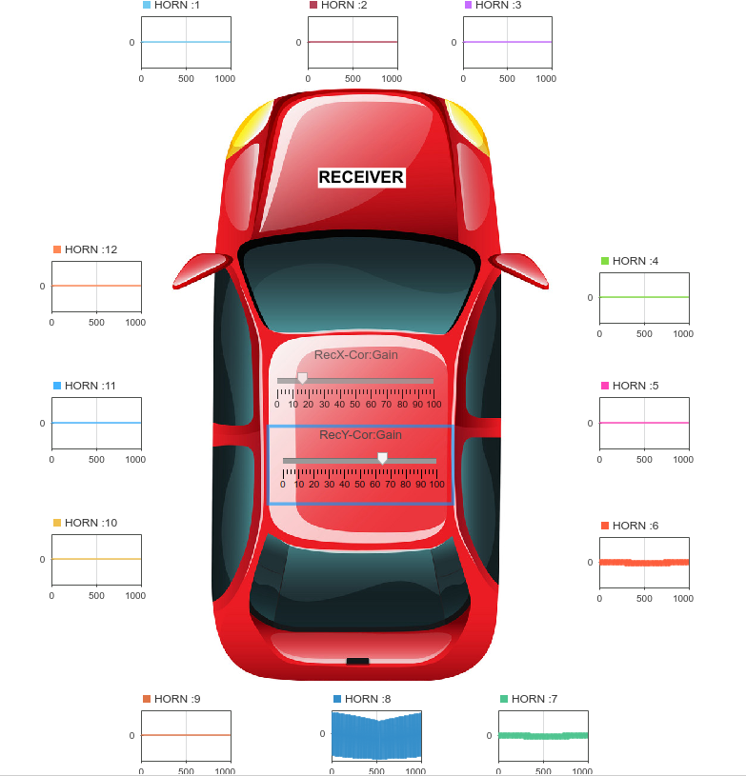

Figure 16. Scenario 2 MATLAB SIMULINK model.

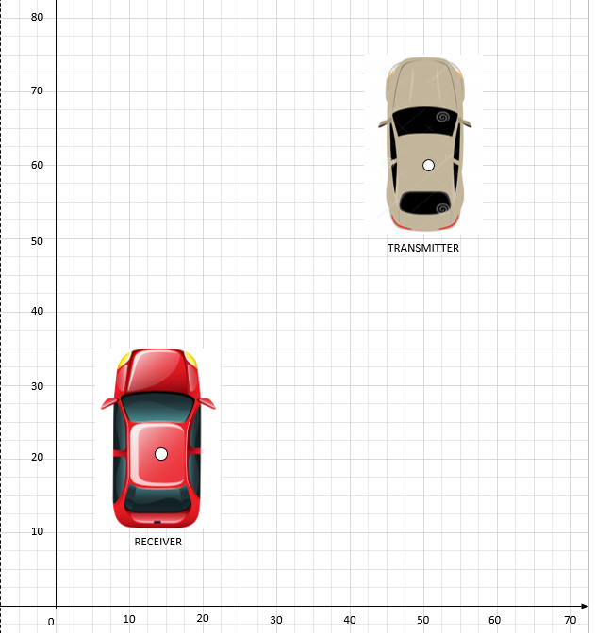

Figure 17. Scenario 3 cartesian plane diagram.

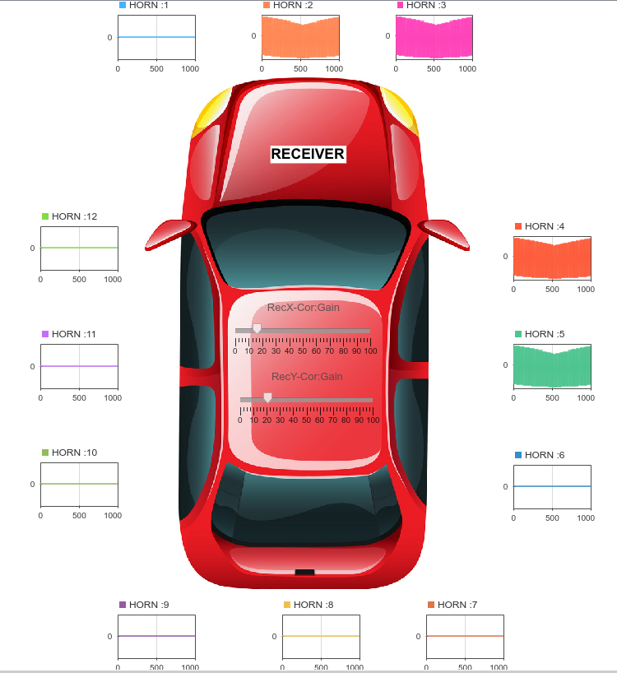

Figure 18. Scenario 3 MATLAB SIMULINK model.

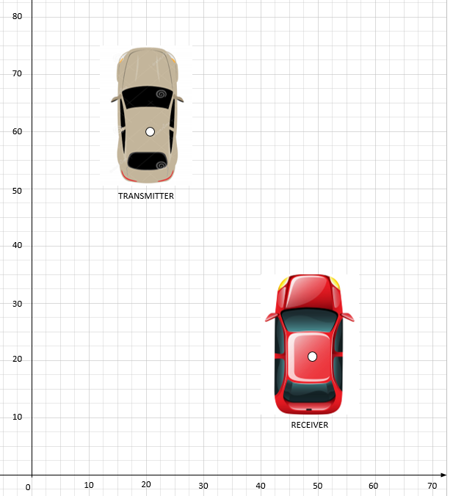

Figure 19. Scenario 4 cartesian plane diagram.

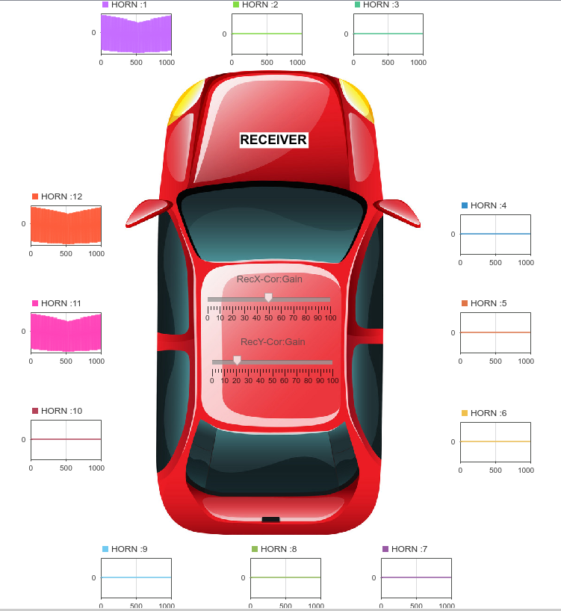

Figure 20. Scenario 4 MATLAB SIMULINK model.

Conclusions

V2V communication-based internal 3-D horn technology expected to revolutionize the use of horn in automobile industries. It solves the purpose of honking without disturbing the environment. Also, it will bring a huge reduction in the noise pollution as compared with the current scenario. The 3-D effect is the most astonishing feature offered by this technology, which enable the whole process to be natural and the driver of the car will feel as if some outside car is honking the horn even though the horns are inside the car. On the other hand, his brain will be able to locate the position of the honking car owing to the 3-D effect. This technology also provides a solution to find out whether the horn is honked for vehicle or a pedestrian. It uses a combination of RADAR and GPS to differentiate between the two entities. If a pedestrian is detected, then an external horn will be honked otherwise internal 3-D horn will be activated. Therefore, this technology provides a unique solution to the problem of noise pollution and can solve it in a safe, reliable and effective way.

**References**

1. [Sadayuki T](https://www.sciencedirect.com/science/article/pii/S0386111214601138#!)sugawa, “Issues and Recent Trends in Vehicle Safety Communication Systems”, International Association of Traffic and Safety Sciences 2004.
2. Luo, Jun; Hubaux, Jean-Pierre, “A Survey of Inter-Vehicle Communication”, EPFL Scientific Publication, 2004
3. Xiubin Wang, “Modeling the process of information relay through inter-vehicle communication”, Transportation Research, 2006.
4. Raya, Maxim; Hubaux, Jean-Pierre, “Security Aspects of Inter-Vehicle Communications”, EPFL Scientific Publication, 2005

Contact Information

Email Address: [shubhamjaiswal.isp@gmail.com](mailto:shubhamjaiswal.isp@gmail.com)

Contact Number: +91 9960410217

Abbreviations

|  |  |
| --- | --- |
| V2V | Vehicle to vehicle |
| GPS | Global Positioning System |
| RADAR | Radio detection and ranging |
| EPA | Environmental protection agency |
| ECU | Engine control unit |